**BANK DATABASE**

**WEEK 3**

# **INPUT:**

create database Bank;

use Bank;

create table Branch

(Branch_name varchar(20) primary key,

branch_city varchar(20),

assets float);

create table BankAccount

(Acc_no int primary key,Branch_name varchar(20),balance real,

foreign key(Branch_name) references Branch(Branch_name) on delete cascade);

alter table Branch modify assets real;

create table BankCustomer

(Customer_name varchar(20) primary key,Customer_street varchar(20),Customer_city varchar(20));

create table Depositer

(Customer_name varchar(20), Acc_no int,

foreign key(Customer_name) references BankCustomer(Customer_name) on update cascade on delete cascade,

foreign key(Acc_no) references BankAccount(Acc_no) on update cascade on delete cascade);

create table Loan

(Loan_no int primary key, Branch_name varchar(20), amount real,

foreign key(Branch_name) references Branch(Branch_name) on update cascade on delete cascade);

insert into branch values('sbi_chamrajpet','bangalore',50000),('sbi_residencyRoad','bangalore',10000),

('sbi_shivajiRoad','mumbai',20000),('sbi_parlimentRoad','delhi',10000),('sbi_jantarmantar','delhi',20000);

select * from branch;

insert into BankAccount values(1,'sbi_chamrajpet',2000),(2,'sbi_residencyRoad',5000),

(3,'sbi_shivajiRoad',6000),(4,'sbi_parlimentRoad',9000),(5,'sbi_jantarmantar',8000);

select * from bankaccount;

insert into BankCustomer values('avinash','bull_temple_road','bangalore'),('dinesh','banerghatta_road','bangalore'),

('mohan','nationalCollege_road','bangalore'),('nikhil','akbar_road','delhi'),('ravi','prithviraj_road','delhi');

select * from bankcustomer;

insert into Depositer values('avinash',1),('dinesh',2),('nikhil',4),('ravi',5),('avinash',8),('mohan',11);

select * from depositer;

insert into bankaccount values (8,'sbi_shivajiRoad',6000),(11,'sbi_chamrajpet',2000);

insert into Loan values (1, 'sbi_chamrajpet',1000),(2,'sbi_residencyRoad',2000),(3,'sbi_shivajiRoad',3000),

(4,'sbi_parlimentRoad',4000),(5,'sbi_jantarmantar',5000);

select * from loan;

# **QUERIES:**

1)

Find all the customers who have at least two accounts at the Main branch (ex.

SBI_ResidencyRoad).

INPUT:select distinct(Customer_name) from Depositer d, BankAccount b where (d.Acc_no = b.Acc_no and b.Branch_name = 'sbi_residencyRoad') having count(*)>1;

OUTPUT:



2)

Find all the customers who have an account at all the branches located in a specific city (Ex. Delhi).

INPUT:

select distinct(Customer_name) from depositer d, Branch b, BankAccount ba where (d.Acc_no = ba.Acc_no and ba.Branch_name = b.Branch_name and b.branch_city = 'delhi');

OUTPUT:

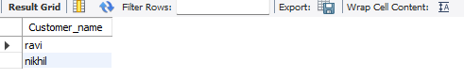

3)

Demonstrate how you delete all account tuples at every branch located in a specific city (Ex. Bombay).

INPUT:

delete from BankAccount where Branch_name in(select Branch_name from Branch where Branch_city = 'mumbai');

select * from BankAccount;

OUTPUT:

2 row(s) affected

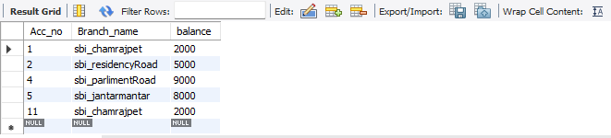

40

Display the branch name and assets from all branches in lakhs of rupees and rename  
the assets column to 'assets in lakhs'.

INPUT:

select Branch_name, Branch_city, (assets/100000) assets_in_lakhs from branch;

OUTPUT:

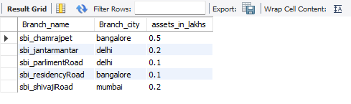

5)

CREATE A VIEW WHICH GIVES EACH BRANCH THE SUM OF THE  
AMOUNT OF ALL THE LOANS AT THE BRANCH.

INPUT:

insert into loan values (6,'sbi_chamrajpet',10000);

create view Loan_sum as select Branch_name,sum(amount) from Loan group by Branch_name;

select * from Loan_sum;

OUTPUT:

0 row(s) affected

